Assignment 3: Validation Rule Scenarios

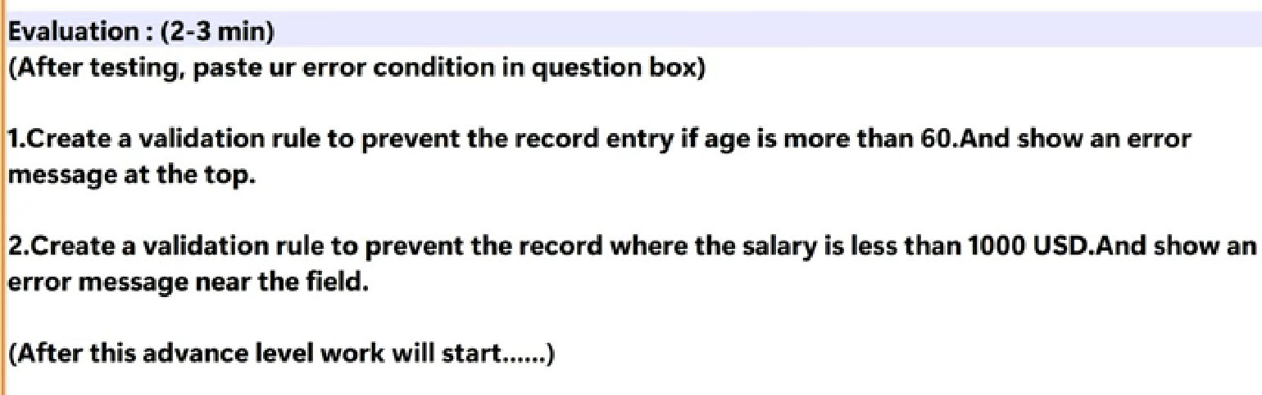

1. Create a Validation rule to prevent the record entry if the age is more than 60. And show an error message at the top

Step 1: Click on the Settings icon
Step 2: Select the Setup option
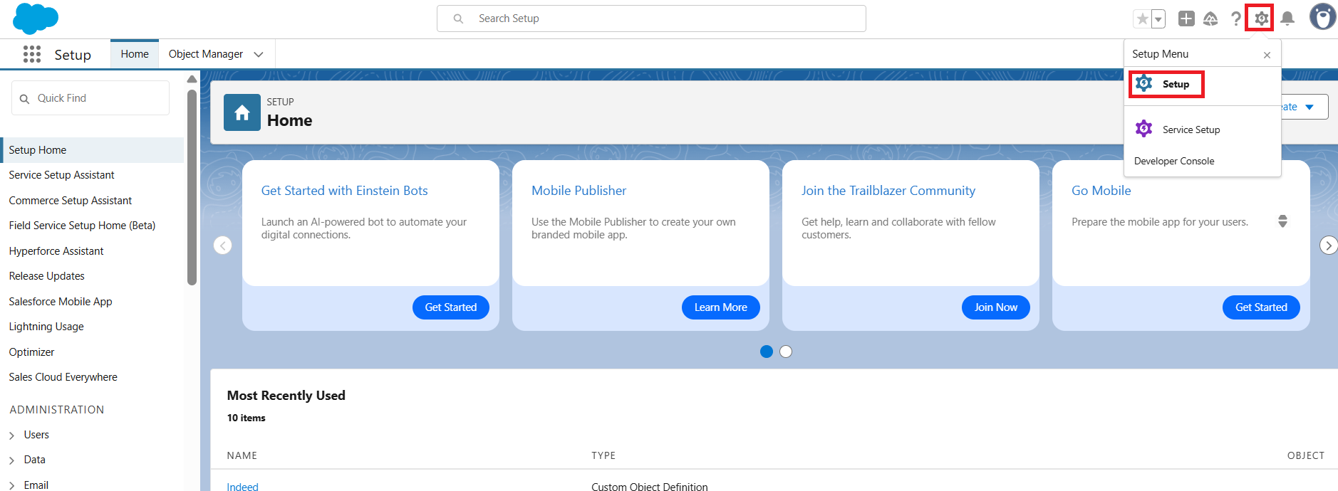

Step 3: Click on Object Manager
Step 4: Search for the Custom Object (Indeed)
Step 5: Click on the Custom Object (Indeed)

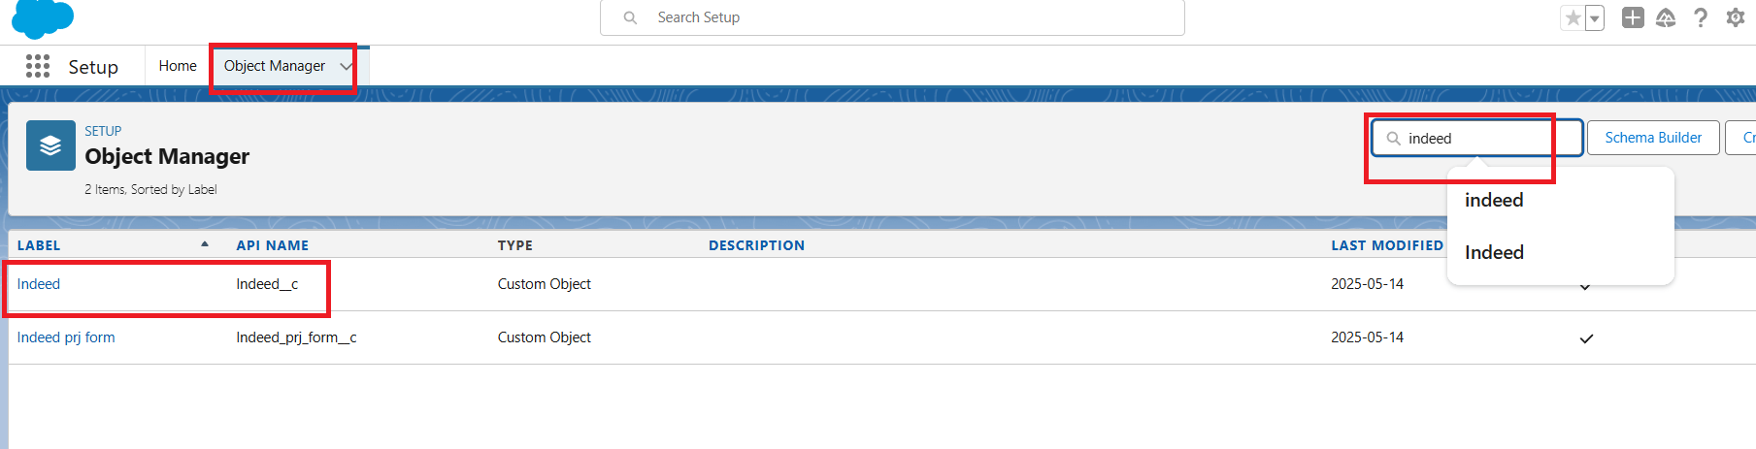
Step 6: Select the Validation Rules option
Step 7: Click on the New Button
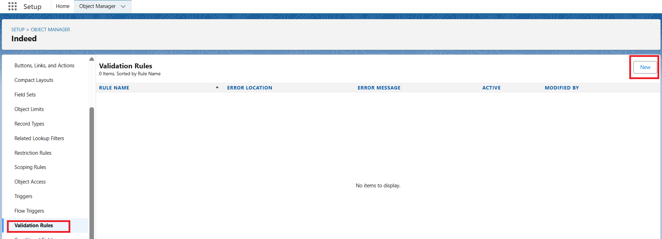

Step 8: Enter Rule Name
Step 9: Enable the Active Checkbox
Step 10: Enter Formula Age_c greater than 60 should throw the error message
Step 11: Enter the Error Message
Step 12: Select the radio button Top (to show the message on the top in classic view)
Step 13: Click on Save

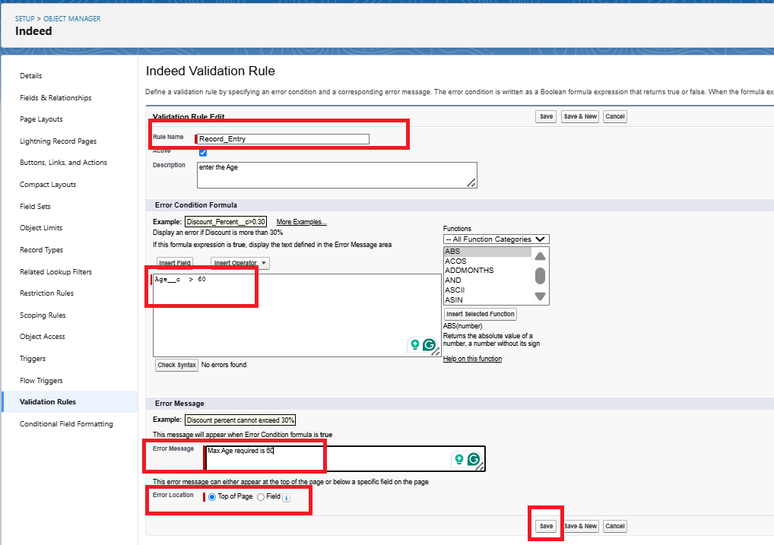

Step 14: Go to the custom object and click on New and check the Age field to validate the data

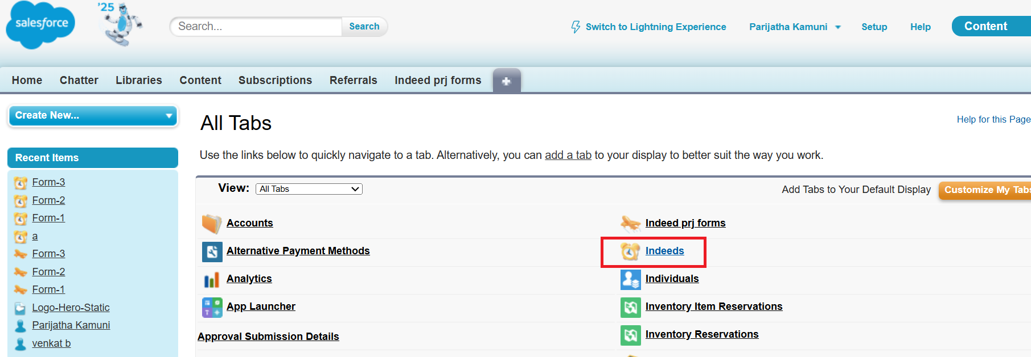
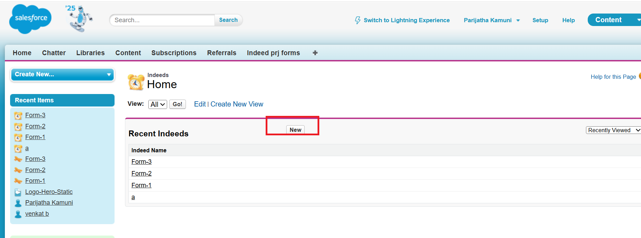

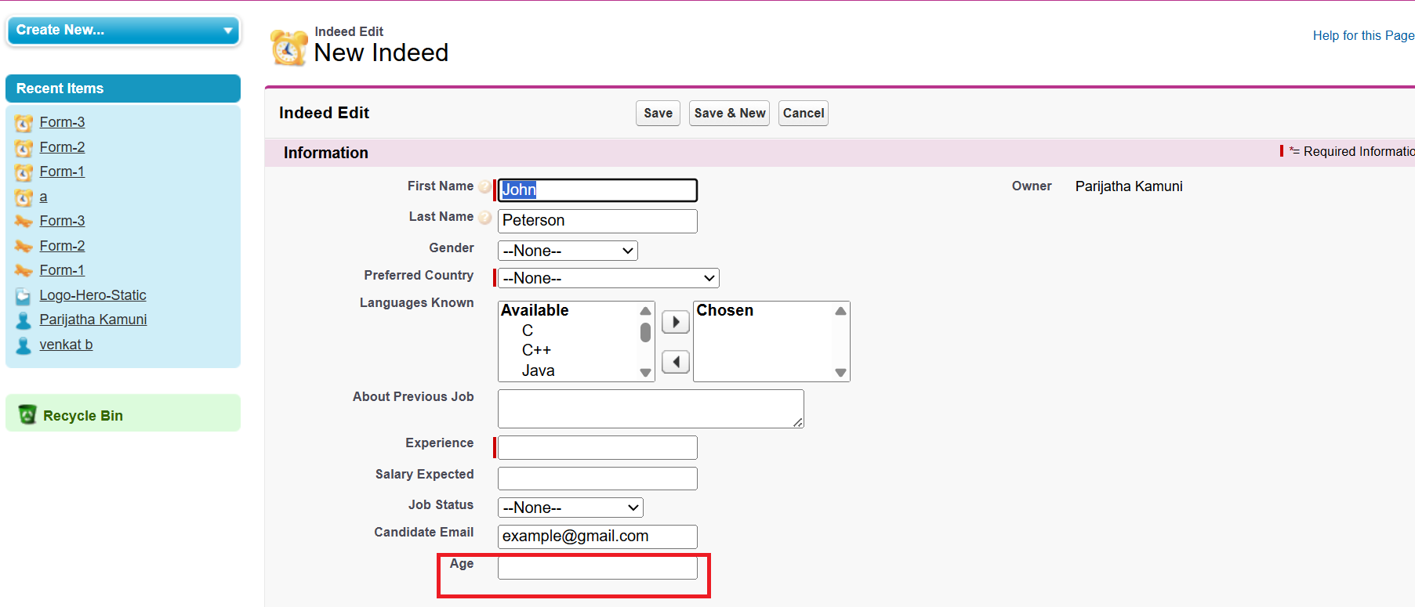

Result
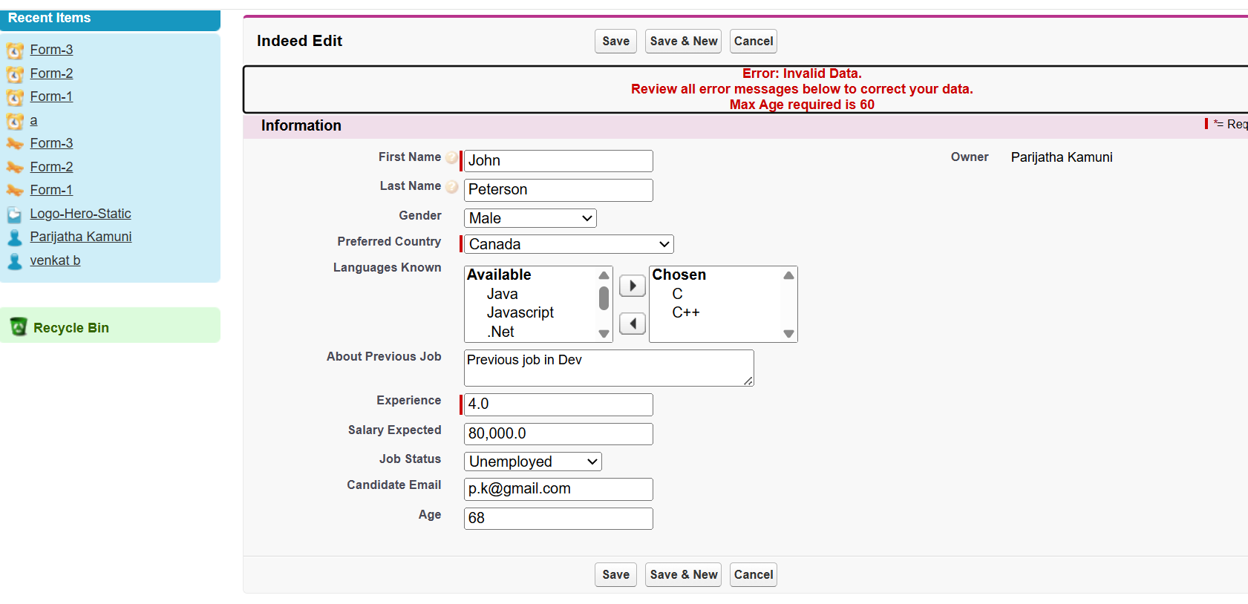

2. Create a Validation rule to prevent the records where the Salary is less than 1000 USD. And show an error message near the field

Step 1: Click on the Settings icon
Step 2: Select the Setup option

Step 3: Click on Object Manager
Step 4: Search for the Custom Object (Indeed)
Step 5: Click on the Custom Object (Indeed)

Step 6: Select the Validation Rules option
Step 7: Click on the New Button

Step 8: Enter Rule Name
Step 9: Enable the Active Checkbox
Step 10: Enter Formula Salary less than 1000 USD should throw the error message
Step 11: Enter the Error Message
Step 12: Select the radio button Field
Step 13: Select the Expected Salasry from the dropdown/picklist
Step 14: Click on Save

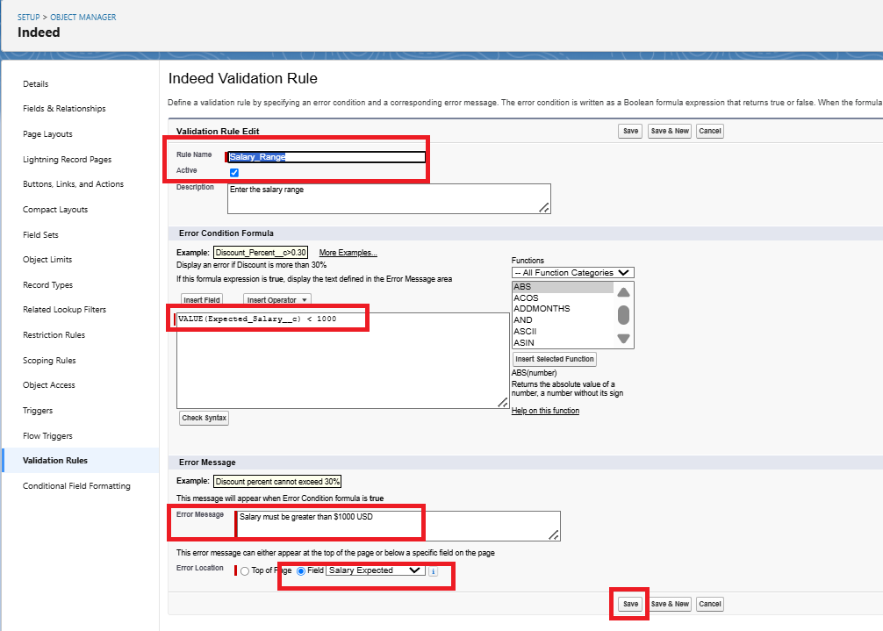

Result
